# JPEG

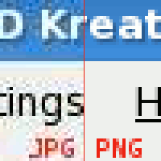JPEG is a file format for digital images.JPEG is found by Joint Photographic Experts Group.JPEG was created in 1992.JPEG is a commonly used method of lossy compression for digital images. JPEG is also the most common format saved by digital cameras.JPEG compression used in a number of image formats like .jpg, .jfif, .jpe.JPEG supports a maximum image size of 65,535x65,535 pixels.

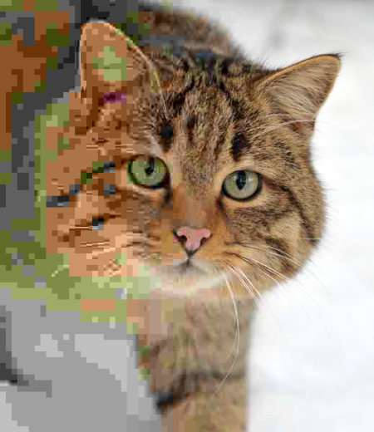The whole reason behind the JPEG file format is to make smaller computer files. Uncompressed photos can be huge data files. By storing the photographic data in the JPEG file format it is possible to reduce the size of data file by as much as 90%. The phrase "as much as" is the critical part of the previous statement.

Photo

The JPEG compression algorithm is at its best on photographs like nature photographs and paintings but JPEG is not good at like line drawings, textual and iconic graphics where the sharp contrasts between adjacent pixels.You can see the example in Photo 1.The lossless compression methods is better for them.

You can adjust the degree of compression, as you can see in Photo 2.The compression rate is decreasing from left to right.JPEG typically achieves 10:1 compression with little perceptible loss in image quality.

Photo